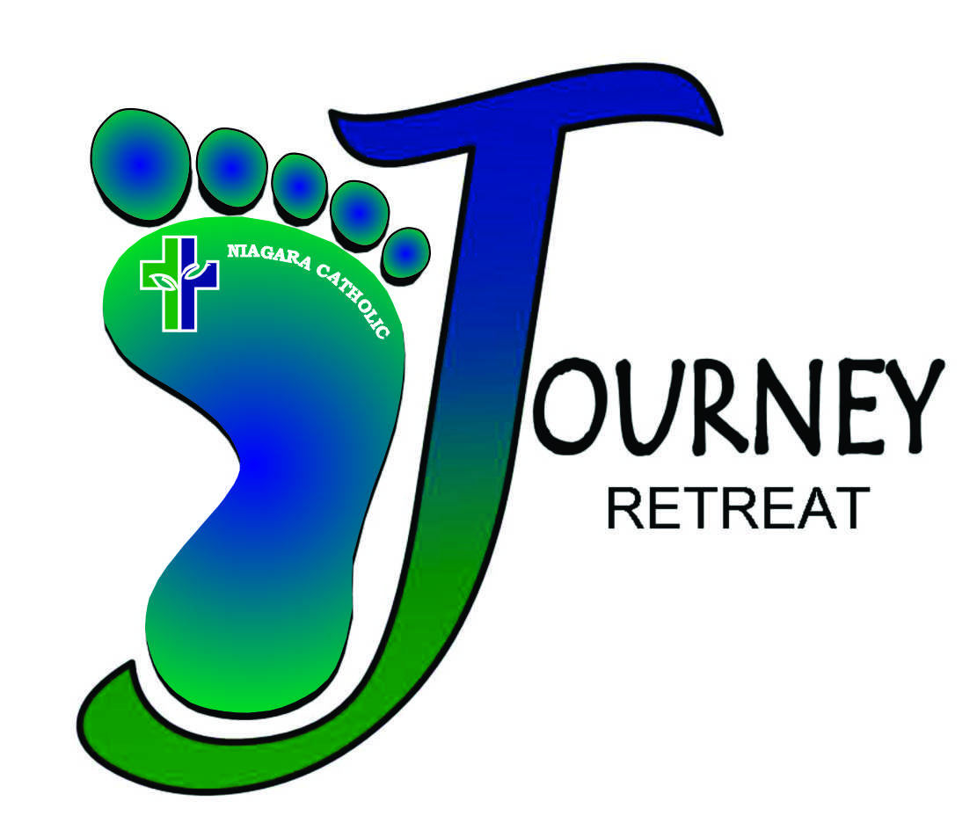

SCHOOL PACKAGE

2019-2020

June 2019

CONTENTS

- Principal check list
- Grade 8 teacher check list
- What Parents Need to Know
- Staff Duties
- Driving Directions

Our Lady of Grace Spiritual Centre
243 Gorham Road
Ridgeway, Ontario

Email: journey@ncdsb.com
Telephone: 905-894-8910

Principal Check List

□ Supervision:

- Arrange for supervision for Day Time and Overnight
(suggested “shift change” Day 1: 4-7pm; 7-10pm; 10pm – overnight.)
- Daytime – ideally male and female
- Nighttime – imperative male and female supervision

Staff Ratio:
- One staff for every 15 students.
- Overnight supervision: administration must ensure a minimum of one supervisor per occupied dorm room.

Discipline:
- Teachers hold primary responsibility for discipline
- One teacher (at least) to be present with students at all times, Journey staff will work with teachers to assure reasonable break times

□ Family Night Dinner:

- Invite school staff to Family Night Mass (5:30)
- Dinner to follow. Max seating for dinner – 120 including students

□ Transportation:

- Ensure that all students have a ride home after Family Night
- At least one staff member must remain with students being picked up after Family Night

□ Double-check with grade 8 teacher - Complete Journey Forms Package (which includes Chartwells’ form for numbers) and submit one week prior to your retreat date.

Scan/email Journey Forms Package to journey@ncdsb.com

(If numbers are not received one week prior, the school will be charged for grade 8 numbers as per organizational chart)

GRADE 8 TEACHER “TO DO” CHECK LIST

Attendance: encourage ALL Grade 8 students to attend!

Parent/ Student Packages: send home with each student

Parish priest - contact to advise of your Retreat dates well in advance to ensure availability.

Collect:

□ Expectation, Information forms and $50 fee

□ $14 per dinner per parent/guest attending Family Night.

- Snacks (prior to boarding bus)

Select/assign:

- Assign students to dorm room and small group (see Forms Package)

Placemats or tent cards:

- Have each student make placemat or tent card with their name for meal time

- # guests attending family night to be written in lower right corner

Family Night notes:

- Ensure that EVERY student has a ride home

- Casual dress for guests, school uniform dress code (blue and white) for students

- Guest numbers may need to be limited – max. seating capacity for dinner is 120

Elementary Chaplaincy Leader visit: approximately TWO WEEKS prior to the Retreat.

□ Complete Journey Forms Package and submit one week prior to your
retreat date.

WHAT PARENTS NEED TO KNOW!
(Parent/Student Package for more details)

- Dates and Times of Retreat –due dates for forms/ payment

- Cost - $50/ student

- Family Night - $14/ person for parent/guest
- they will be taking their child home following dinner (approximately 7:15 pm)
- If they cannot attend, they must make alternative arrangements for their child.
- Family Night attire is casual but still appropriate for attending Mass, school uniform dress code (blue and white) for students

- Pack – all necessary items…. Including appropriate outdoor wear. We go outside in all types of weather.

- Electronics – including cell phones are not allowed.
Our Lady of Grace Spiritual Centre: 905-894-8910

- Snacks – Everyone is asked to bring a healthy snack that will be shared with the entire class during scheduled snack times.

- Water Bottles – In the interest of the environment, ecological justice and responsible social ethics, we insist that students bring their own refillable water bottles.

- Students will be sent home for vandalism, violence, visiting other dorms, and excessive disrespectful behavior. Parents will be responsible for damages.

- All medications must be given to the Teacher to hold and administer.

STAFF SUPERVISORY DUTIES WHILE AT THE RETREAT

- PARTICIPATE with your students and assist with all sessions and activities!

- Set up and supervise Snack Times
(kitchen juice & milk are for meals only)

- Assist and supervise at Meal Times.

- Supervise ‘free time’ in dorms and/or gym.

- Deal with discipline problems should they arise.

- Ensure that there are absolutely no snacks or gum in dorms.

7. DAY ONE EVENING PROGRAM –
Plan and supervise evening activities from approximately 6:45 pm to 10:30 pm.

Suggestions: Snack, Shower Time, Table Games, Gym Time (large group games), Talent Night

8. Have students in their own Dorm rooms by 10:30 pm with lights
out at 11:00pm…… hopefully, asleep no later than midnight! Day two activities are very difficult when everyone is tired.

9. DAY TWO MORNING –
Wake students by 7:30a.m. Students need to clean up their
Dorm and pack most of their gear before breakfast. Breakfast
will be at 8:00am and all students must be on time and present.
Everyone must be ready for 9:00am to begin Journey Retreat activities.

- Chapel – This is a sacred space. No food or drink is
permitted.

Driving Directions from Grimsby, Niagara Falls, St.Catharines to Our Lady of Grace Spiritual Centre

- Follow Queen Elizabeth Way toward Fort Erie
- Take exit #16 / Sodom Road south to Crystal Beach – go 3.4 Km.
- Drive past Zoo’s and Stevensville Nursery
- Sodom Rd. becomes (same RR-1) Stevensville Road, then Gorham Rd. – go .9km
- Continue into Ridgeway, Our Lady of Grace is just after Joe’s Value Mart
- Address: 243 Gorham Road, Ridgeway.

Driving Directions from Smithville, Wainfleet, Port Colborne to Our Lady of Grace Spiritual Centre

- Follow Provincial Highway 3 – go 39.6 Km
- Turn right onto Gorham Road / RR -116 – go .9 miles
- Continue into Ridgeway and Our Lady of Grace is just after Joe’s Value Mart
- Address: 243 Gorham Road Ridgeway

Driving Directions from Welland to Our Lady of Grace Spiritual Centre

- Follow East Main Street – through tunnel
- Turn right onto Ridge Rd. Travel to Netherby Road turn left
- Take Netherby Road to Stevensville Road @ Snyder, turn right
- Travel along Stevensville Rd. (past Zoos, Stevensville Nursery). Stevensville Rd. becomes Gorham Rd.
- Continue into Ridgeway and Our Lady of Grace is just after Joe’s Value Mart
Address: 243 Gorham Road, Ridgeway

